API Security Risk Analysis Report

Future Interns Project
Cyber Security Task 3

Prepared by:
Khushi Patel

Abstract

This internship report documents the design development and learning outcomes of the Phishing Email Detection & Awareness System, completed as part of a future-oriented internship program. The Project focuses on identifying phishing emails using rule-based detection techniques while simultaneously improving user awareness through alerts and educational guidance. The internship enhanced practical kills in cyber security, web development, and secure system design.

Introduction

This report presents an API Security Risk Analysis Performed on a public test API. The purpose of this assessment is to identify common API security issues such as missing authentication , authorization flaws, excessive data expose, and lack of input validation. The testing was conducted using safe and legal methods for learning purpose.

- API details

- API Name : JSONPlaceholder public API
- Base URL: https://jsonplaceholder.typicode.com
- Type: Public Test REST API
- Purpose: Used for testing and learning API requests

- Tools

- Postman – API testing
- Browser – API reference
- Browser developer tools
- Google docs / MS word / PDF for Documentation

- Methodology

The API was tested manually using Postman by sending different types of HTTP requests.
The following security checks were performed:
- Authentication testing
- Authorization testing
- Sensitive data exposure check
- Input validation testing
- Rate limiting observation

API Endpoints Tested

Method | Endpoint
GET | /posts
GET | /posts/{id}
GET | /users
POST | /posts

Findings & Risks

Risk 1: Missing Authentication on Some Endpoints
Description: Certain API endpoints were accessible without requiring login tokens.
Impact: Attackers may retrieve or manipulate sensitive data.
Recommendation: Enforce authentication using API keys or OAuth tokens for all protected routes.

🔴 Risk 2: Weak Authorization Checks
Description: Users may access resources belonging to other users.
Impact: Data privacy violation and unauthorized data exposure.
Recommendation: Implement role-based or user-based access validation.

🟠 Risk 3: No Rate Limiting
Description: Unlimited requests can be sent to the API.
Impact: Risk of brute force attacks and server overload.
Recommendation: Apply request throttling and monitoring.

🟠 Risk 4: Excessive Data Exposure
Description: API responses return more data than required.
Impact: Sensitive information leakage.
Recommendation: Filter and return only necessary fields.

🟡 Risk 5: Improper Error Messages
Description: Detailed system errors are visible.
Impact: Attackers gain system information.
Recommendation: Use generic error responses.

Proof of work

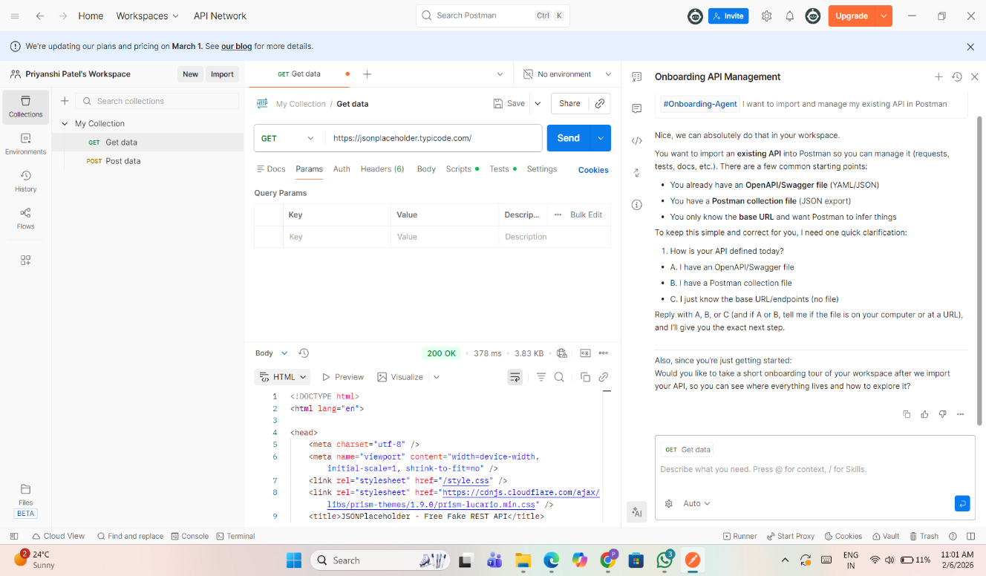

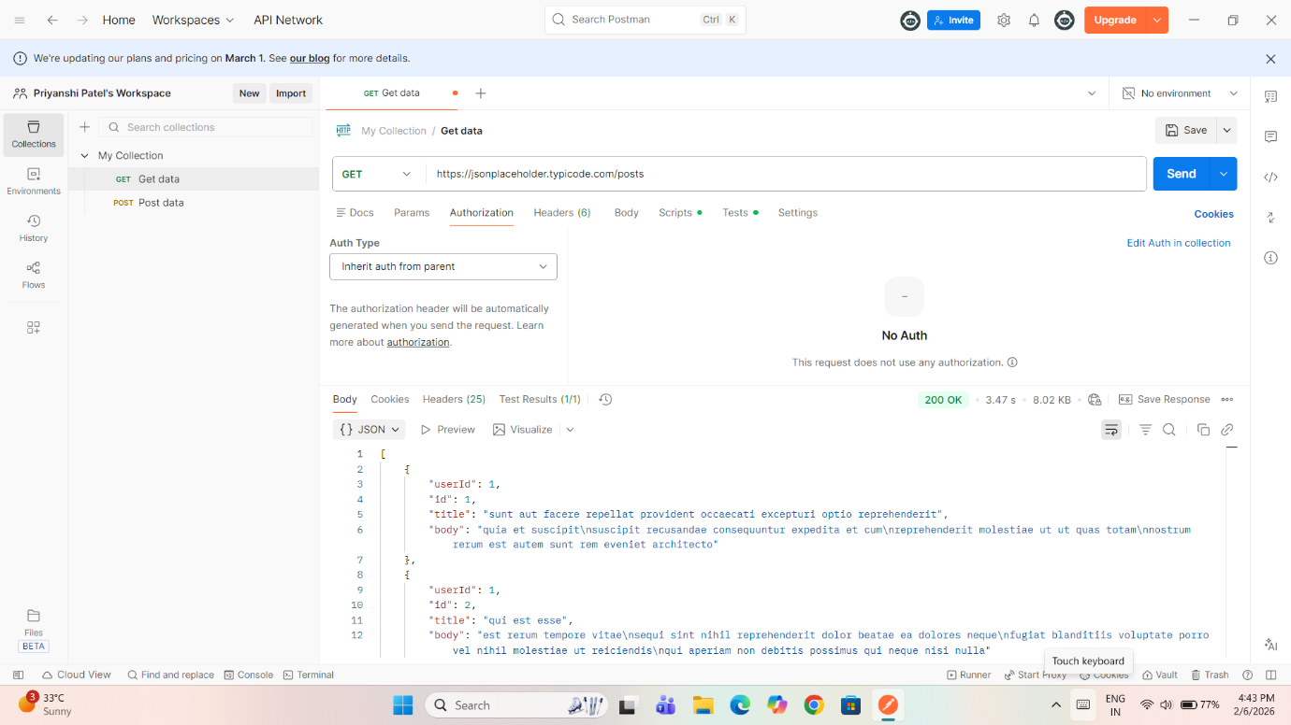

- Missing Authentication
Description:
The API allows access to data without requiring any authentication such as API keys or tokens.
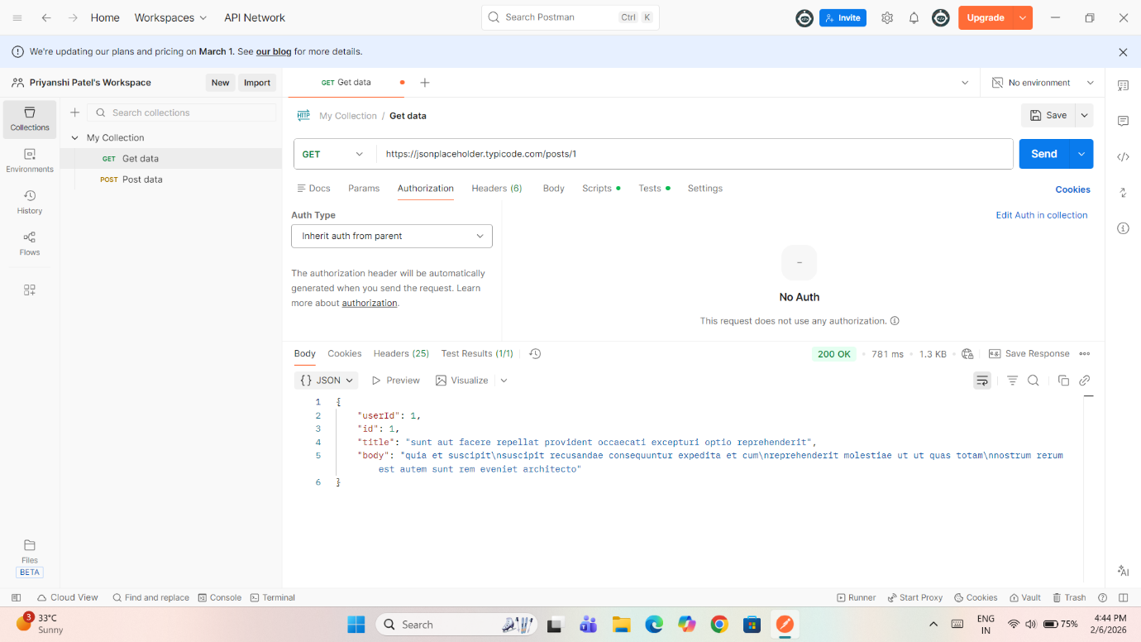
Impact:
Anyone can access the API data, which may lead to unauthorized use.
Severity: High

- Broken Object Level Authorization (BOLA)
Description:
By modifying the ID value in the URL, different user data can be accessed.
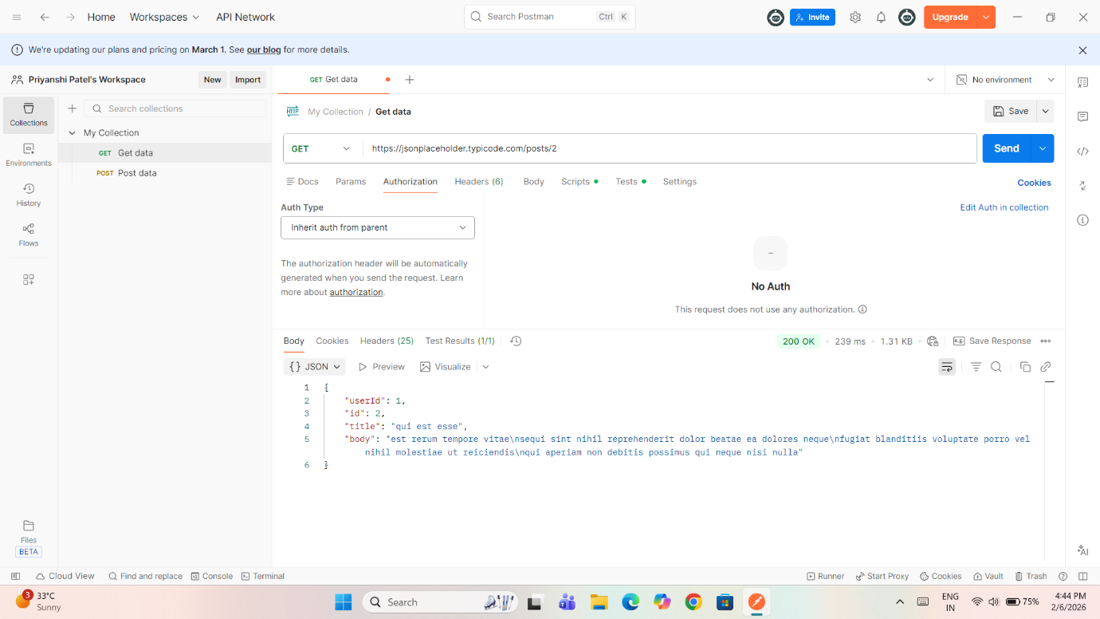

Impact:
Attackers can access or manipulate other users’ data.
Severity: High

- Excessive Data Exposure
Description:
The /users endpoint exposes sensitive information such as email, phone number, and address.

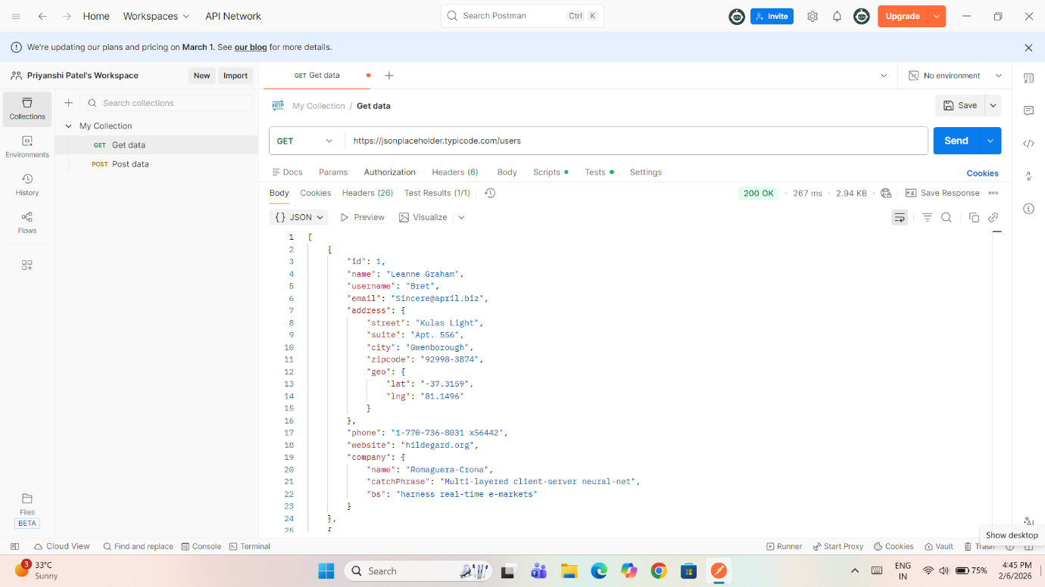

Impact:
Sensitive user data leakage can lead to privacy issues.
Severity: Medium

- Missing Input Validation
Description:
The API accepts invalid and malicious input without proper validation.
Impact:
This may lead to injection attacks and application compromise.
Severity: High

- No Rate Limiting
Description:
Multiple requests can be sent continuously without restriction.
Impact:
The API is vulnerable to Denial of Service (DoS) attacks.
Severity: Medium

Risk Summary Table

Risk | Endpoint | Impact | Severity
Missing Authentication | /posts | Unauthorized access | High
BOLA | /posts/{id} | Data exposure | High
Excessive Data Exposure | /users | Privacy risk | Medium
Missing Input Validation | POST /posts | Injection risk | High
No Rate Limiting | All | DoS attack | Medium

Improve user cybersecurity awareness

Recommendations

- Implement authentication mechanisms such as JWT or API keys
- Apply role-based access control for authorization
- Limit sensitive information in API responses
- Validate and sanitize all user inputs
Enforce rate limiting to prevent abuse

Conclusion

The API requires improvements in access control, request validation, and monitoring. Applying the recommended fixes will significantly reduce the risk of unauthorized access and strengthen overall security.

Thank you

